Medicare Cloud – Phase 2: Org Setup & Configuration

**Goal:** Prepare Salesforce environment for healthcare use case (patients, appointments, claims, care plans) with a secure, structured, and efficient setup

# Salesforce Edition

* + Developer Edition (Free Dev Org) for prototype development.
  + Future: Health Cloud license for production to leverage prebuilt healthcare objects like Care Plans, Patient Profiles, and Patient Engagement tools.
  + Purpose: Low-cost, flexible environment for testing workflows, object relationships, and automation.

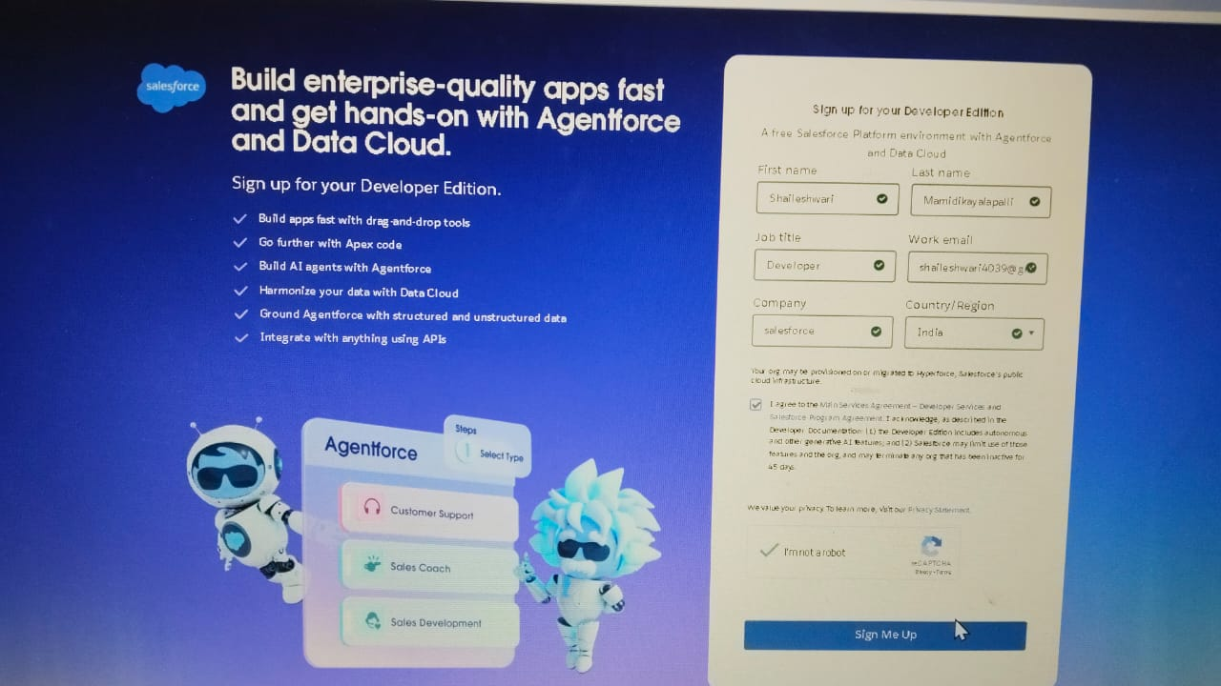

# Company Profile Setup

* + Setup → Company Settings → Company Information
  + Add:
    - Company Name: Medicare Cloud Pvt Ltd
    - Time Zone: IST (India Standard Time)
    - Currency: INR (₹) or USD ($) depending on project scope
  + Additional Configuration: Locale, language, and default business hours to standardize record creation and reporting.
  + Purpose: Accurate time and currency settings ensure proper scheduling, reporting, and workflow processing.
  + 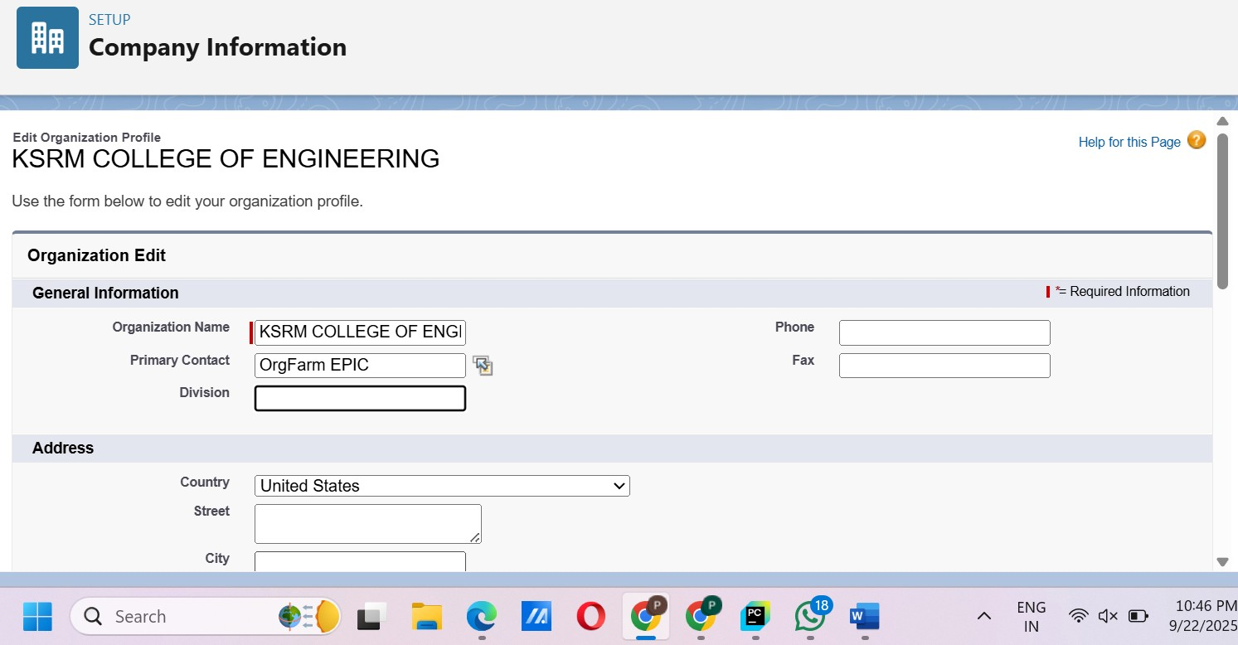

# Business Hours & Holidays

* + Business Hours: Setup → Quick Find → Business Hours → New
    - Example: Mon–Sat, 09:00–18:00

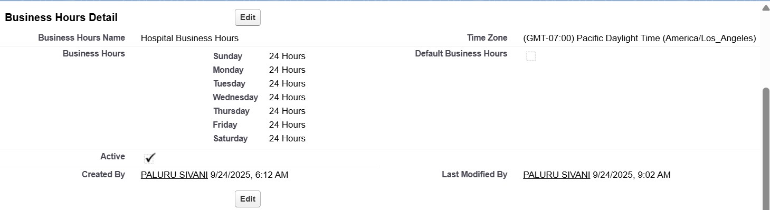

* + Holidays: Setup → Quick Find → Holidays → New
    - Suggested: New Year, Republic Day, Independence Day, Diwali, Christmas,

Hospital Annual Maintenance Day

* + - Mark as Active.
  + Purpose: Workflows, approval processes, and scheduling respect working hours and holidays.
  + 

# Fiscal Year Settings

* + Setup → Quick Find → Fiscal Year
  + Use Standard (Jan–Dec)
  + Purpose: Aligns with revenue reporting, insurance claim cycles, and hospital budgeting.

# User Setup & Licenses

* + Create hospital user roles:
    - Doctor: Salesforce license, Doctor Profile
    - Nurse: Salesforce license, Nurse Profile
    - Insurance Officer: Salesforce license, Insurance Profile
    - Admin: System Administrator
  + Assign role, profile, and permission sets at creation.
  + Purpose: Ensures proper access control and workflow responsibilities.

# Profiles

* + Setup → Profiles → Clone Standard User/Admin → Name appropriately → Assign to users
  + Suggested Profiles:
    - Doctor: Create/edit patients & appointments, view claims
    - Nurse: Update appointments & patient notes
    - Insurance Officer: View & update claims only
    - Admin: Full access
  + Future Steps: Assign object-level permissions for custom objects once created.
  + Purpose: Baseline access for users, with flexibility via permission sets.

# Roles (Hierarchy)

* + Setup → Roles → Set Up Roles
  + Suggested hierarchy:

Hospital Director

└─ Doctor

└─ Nurse

Insurance Officer (separate branch)

* + Purpose: Controls record visibility roll-up; higher roles can see records owned by lower roles.

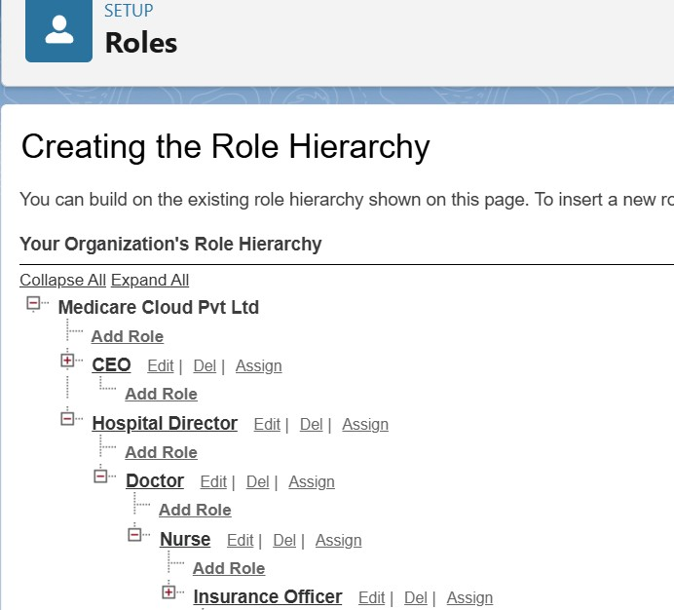

* + Verification: Test by logging in as lower-role users to ensure visibility is correct.

# Permission Sets

* + Setup → Permission Sets → New → Configure → Assign to users
  + Suggested Permission Sets:
    - Reports_Access: Run reports, view dashboards
    - Telemedicine_Access: Access telemedicine apps and pages
  + Purpose: Grant additional access without modifying profiles, ideal for temporary or role- specific needs.
  + Assignment: Users can have multiple permission sets simultaneously.
  + 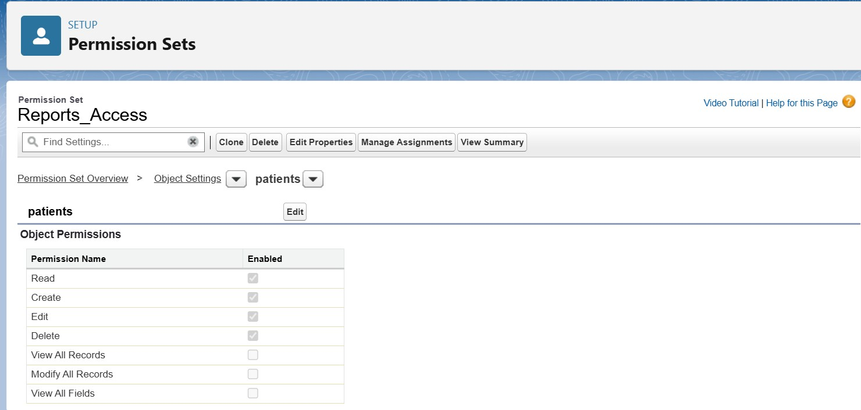

# Org-Wide Defaults (OWD)

* + Patient c: Private (only owner/doctor/manager sees)
  + Appointment c: Public Read Only (staff can view schedules)
  + Insurance_Claim c: Private (only relevant users can see)
  + Purpose: Protects sensitive patient and claim information by default.

# Sharing Rules

* + Setup → Sharing Settings → New Rule → Define criteria → Assign access
  + Example: Cardiology doctors see each other’s patients.
  + Purpose: Provide exceptions to OWD while maintaining data privacy.

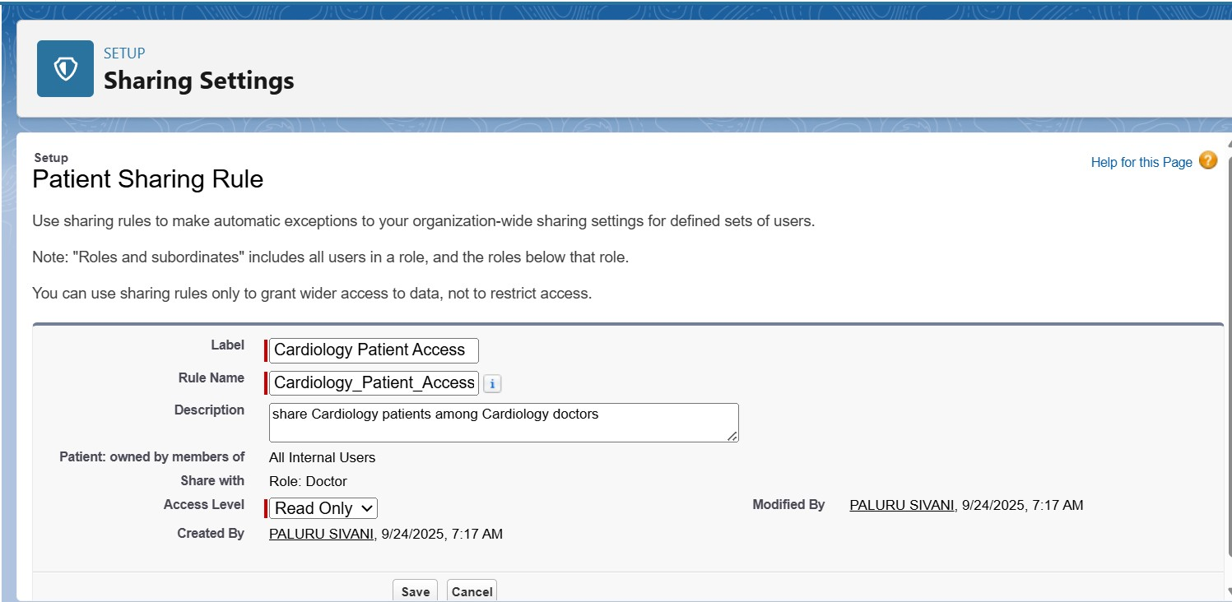

# Login Access Policies

* + Restrict login hours:
    - Doctors/Nurses: 09:00–18:00
    - Admin: 24x7
    - Insurance Officer: restricted as needed
  + Optional: Restrict by IP range for sensitive hospital networks.
  + Purpose: Enhances security and ensures compliance with hospital policies.

# Dev Org Setup

* + Developer Org acts as a sandbox to build and test:
    - Custom objects (Patient c, Appointment c, Insurance_Claim c, Care_Plan c)
    - Automation (Flows, Process Builder, Workflows)
    - Permissions, layouts, and apps
  + Purpose: Safe testing environment without affecting production data.

# Sandbox Usage (Future Production)

* + Recommended workflow:

1. Build/test in Sandbox
2. Conduct UAT (User Acceptance Testing)
3. Deploy to Production using Change Sets or Salesforce CLI
   * Purpose: Ensures changes are validated and reduces production risks.

# Deployment Basics

* + Package metadata: objects, fields, profiles, permission sets, roles, workflows, flows
  + Deploy to Production → Validate → Activate
  + Maintain deployment documentation with metadata changes and order
  + Purpose: Streamlined, controlled deployment of changes to live environment.

# Summary

Phase 2 ensures that Salesforce is secure, structured, and ready for healthcare workflows. By completing this phase, you achieve:

* + User accounts, profiles, and roles configured
  + Permission sets created and assigned
  + OWD and sharing rules implemented
  + Business hours and holidays configured
  + Dev Org ready for custom object creation and automation
  + Deployment strategy defined for Production rollout